Project Design Phase-II
Technology Stack (Architecture & Stack)

Date | 18 june 2026
Team ID
Project Name | ShopEZ
Maximum Marks | 4 Marks

Technical Architecture:
ShopEZ

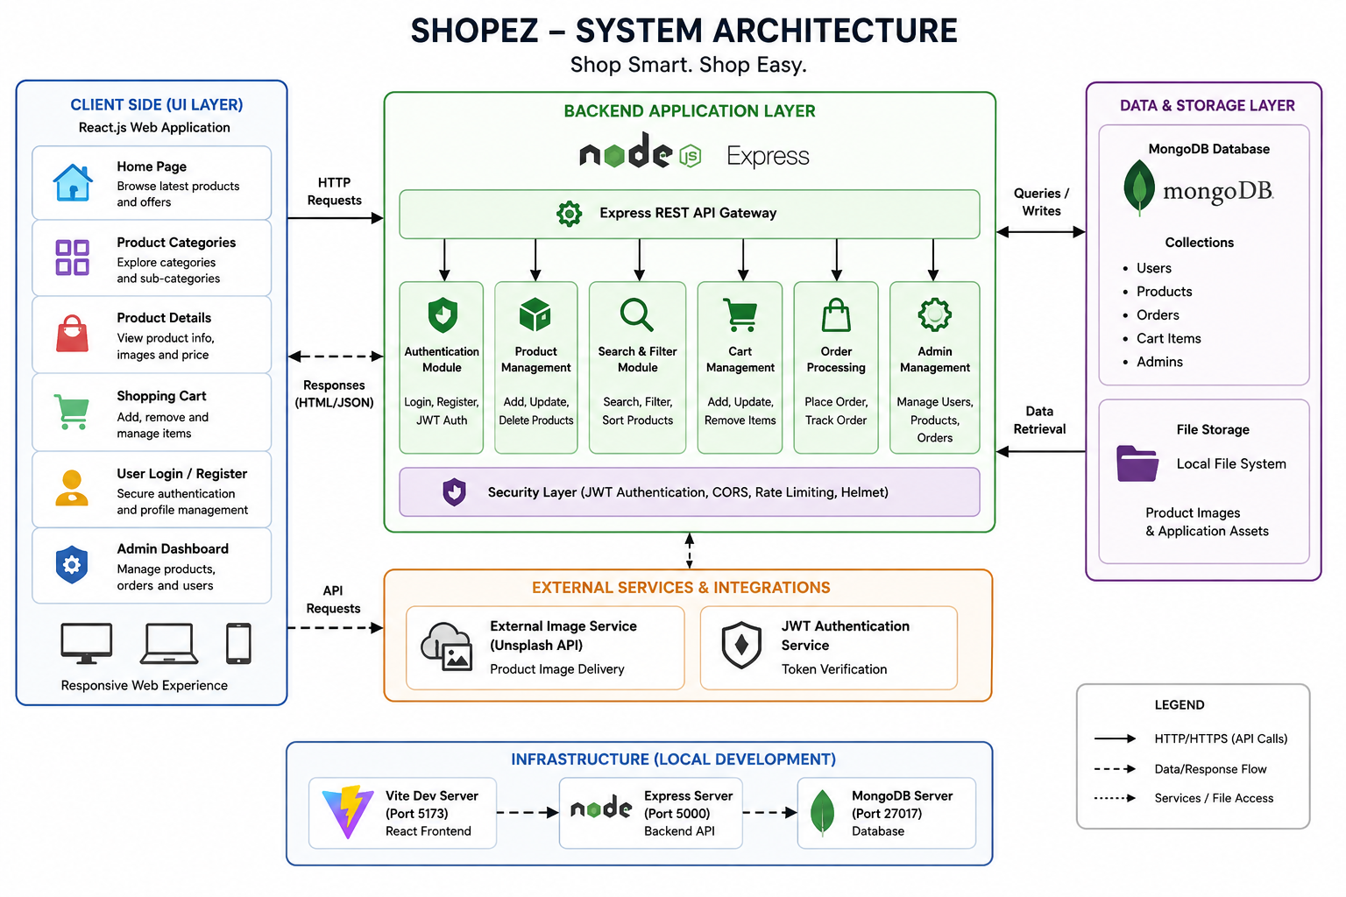

Table-1 : Components & Technologies:
S.No | Component | Description | Technology
 | User Interface | Responsive E-Commerce Web Application for customers and admins to browse products, manage cart and orders | HTML5, CSS3, JavaScript ES6+, React.js, Vite
 | Application Logic-1 | User Registration, Login Authentication and Session Management | Node.js, Express.js, JWT
 | Application Logic-2 | Product Listing, Search, Category Filtering and Product Management | Node.js, Express.js
 | Application Logic-3 | Shopping Cart Operations, Checkout Workflow and Order Processing | Node.js, Express.js
 | Database | Stores Users, Products, Orders and Cart Information | MongoDB, Mongoose ODM
 | Cloud Database | Cloud-based deployment support | MongoDB Atlas
 | File Storage | Product Images and Application Assets | Local File System Storage
 | External API-1 | Product Image Delivery Services | Unsplash API / External URLs
 | External API-2 | Authentication Token Verification | JWT Authentication
 | Machine Learning Model | Not Applicable | N/A
 | Infrastructure (Server / Cloud) | Frontend: Vite (5173), Backend: Express (5000), Database: MongoDB | Local Host Node Runtime

Table-2: Application Characteristics:
S.No | Characteristics | Description | Technology
 | Open-Source Frameworks | Uses open-source libraries for rapid development and community support | React.js, Express.js, MongoDB, Mongoose
 | Security Implementations | Secure authentication, password protection and protected APIs | JWT, Middleware Security, Route Protection
 | Scalable Architecture | 3-Tier Architecture separating UI, Backend and Database | React + Express + MongoDB
 | Availability | Stateless REST APIs for reliable application availability | JWT Authentication, REST APIs
 | Performance | Optimized rendering, efficient queries and fast frontend loading | Vite, MongoDB Optimization, React Rendering

